Single Image Super Resolution using ESRGAN, EDSR and WDSR

Srinidhi Chandrasekaran
School of Computer Science and Engineering
Vellore Institute of Technology
Chennai, Tamil Nadu, India
srinidhi.chandrasekaran@gmail.com
Mohanapriya Singaravelu
School of Computer Science and Engineering
Vellore Institute of Technology
Chennai, Tamil Nadu, India
<EMAIL ID>
Harini Jaishanker
School of Computer Science and Engineering
Vellore Institute of Technology
Chennai, Tamil Nadu, India
<EMAIL ID>

Abstract—EDSR and WDSR are single image super resolution algorithms based on deep convolutional neural networks. They directly learn the complete mapping between low-resolution image and high-resolution image. ESRGAN is a perceptual-driven approach based on generative adversarial networks that can produce photorealistic images. Here, we attempt to compare the three models using PSNR values.
Keywords—image, super resolution, PSNR, GAN, CNN

Introduction (Heading 1)
Image super-resolution (SR) is the process of recovering high-resolution (HR) images from low-resolution (LR) images. It is an important class of image processing techniques in computer vision and image processing and enjoys a wide range of real-world applications, such as medical imaging, satellite imaging, surveillance and security, astronomical imaging, amongst others.
Recently, deep neural networks provide significantly improved performance in terms of peak signal-to-noise ratio (PSNR) in the SR problem. However, such networks exhibit limitations in terms of architecture optimality. EDSR and WDSR are developed by optimizing, analyzing, and simplifying SRResNet architecture. They need to be trained with appropriate loss functions since training a network becomes nontrivial when the model is complex.
Since the pioneer work of SRCNN proposed by Dong et al. [8], deep convolution neural network (CNN) approaches have brought prosperous development. Various network architecture designs and training strategies have continuously improved the SR performance, especially the Peak Signal-to-Noise Ratio (PSNR) value [21,24,22,25,36,37,13,46,45]. However, these PSNR oriented approaches tend to output over-smoothed results without sufficient high-frequency details, since the PSNR metric fundamentally disagrees with the subjective evaluation of human observers [25].
The models are trained on DIV2K bicubic downscaled dataset and the obtained PSNR values are compared.

RELATED WORK
There is a lot of research work done in the field of image super resolution. It has opened up opportunities in many avenues including medicine, health, space and satellite, automation industry and many more.
In the past, image super resolution algorithms were based on image processing and statistical techniques. Li et al. [5] and Nasrollahi et al. [6] classified image super-resolution methods into three different groups, namely, interpolation-based method, reconstruction-based method, and learning-based method (Fig 1). Interpolation based methods are simple but could not capture the high-frequency details of the image and restore them. The reconstruction-based method includes the sharpening of edge details [11], regularization [12,13], and deconvolution [14] techniques. The learning-based method has an advantage over the interpolation-based method by restoring the missing high-frequency details through a relationship established between the LR image and the HR image.
With the advent of deep learning, convolutional neural networks were used for improvising the resolution of an image. Algorithms like SRCNN, VDSR, FSRCNN and ESPCNN are deep learning based convolutional neural networks designed to improve the resolution of an image [16].
This was followed by residual networks. They were much deeper than CNNs and were used for reconstruction of images. EDSR, WDSR, EBRN [] are all residual networks with a recursive restoration model for single image super resolution.
In 2014, Ian Goodfellow proposed a method called GAN (generative adversarial network) for super resolution of images []. This paper sparked off a series of many algorithms using GANs. First and the most basic amongst them is SRGAN (Super Resolution GAN) []. ESRGAN is an enhanced SRGAN with a perceptually improvised loss function []. ESRGAN was further advanced into ESRGAN+ [].

PROPOSED METHODS
This paper compares the EDSR, WDSR and ESRGAN models designed for single image super resolution based on the PSNR values of the high-resolution images produced by them. The standard DIV2K bicubic dataset has been used for training and testing the models.

EDSR
EDSR is based on ResNet architecture. Although Ledig et al. [14] successfully applied the ResNet architecture to the super-resolution problem with SRResNet, Lee et al [] further improved the performance by employing better ResNet structure.
EDSR removed the batch normalization layers from the network. Since batch normalization layers normalize the features, they get rid of range flexibility from networks by normalizing the features, it is better to remove them. Furthermore, GPU memory usage is also sufficiently reduced since the batch normalization layers consume the same amount of memory as the preceding convolutional layers. In each residual block, constant scaling layers are placed after the last convolution layers. These modules stabilize the training procedure greatly when using a large number of filters. The model has 32 layers and 256 feature channels with a scaling factor of 0.1. Then the images are up sampled as required (×2, ×3 or ×4).

WDSR
The intuition of WDSR is that expanding features before ReLU allows more information to pass through while keeps the highly non-linearity of deep neural networks. Thus, low-level SR features from shallow layers may be easier to propagate to the final layer for better dense pixel value predictions. WDSR has two variants of residual networks, namely, WDSR-A and WDSR-B. WDSR-A and WDSR-B are built on the principle of wide activation with weight normalization.

ESRGAN
ESRGAN has a SRResNet based architecture with residual-in-residual blocks. It is a mixture of context, perceptual, and adversarial losses. Context and perceptual losses are used for proper image upscaling, while adversarial loss pushes neural network to the natural image manifold using a discriminator network that is trained to differentiate between the super-resolved images and original photo-realistic images.

PSNR
PSNR is peak signal to noise ratio. It is the ratio between the maximum possible power of an image and the power of corrupting noise that affects the quality of its representation. To estimate the PSNR of an image, it is necessary to compare that image to an ideal clean image with the maximum possible power.

RESULTS AND DISCUSSION

Figure 2 shows the sample result for EDSR on the Lena image. The LR image was obtained by doing bicubic downscaling by a factor of 4. The low-resolution image is highly pixelated with jagged edges. While the SR image obtained has a significant improvement in terms of defining crisp edges, the finer details present in the input HR image are not preserved. This explains the low PSNR value of 5.1907578 obtained. Meanwhile, ESRGAN has a significantly higher PSNR value of 29.865347. The resulting SR image shows the level of details that are absent in EDSR’s result - the crinkles on the hat are more defined and the image is a lot smoother. The texture of the image in ESRGAN is more realistic.

Conclusion

The two models evaluated are effective in improving the resolution of the image. ESRGAN performs significantly better than EDSR in terms of PSNR values. Currently, PSNR is currently the only Image Quality Assessment metric being used to evaluate the outputs. However, for a true single image super-resolution task, a reference image will not be available, highlighting the need for non-reference Image Quality Metrics. Image super-resolution has various applications in medical imaging and video assessments. The future scope of this experimentation can be training the model specifically for such use cases. Figures and Tables.

TABLE 1: Lena image

Model | PSNR
EDSR | 5.1907578
ESRGAN | 29.865347

TABLE 2: Demo image 1

Model | PSNR
EDSR | 7.2139854
ESRGAN | 24.676704

TABLE 3: Demo image 2

Model | PSNR
EDSR | 9.9496
ESRGAN | 21.897034



References

- G. Eason, B. Noble, and I. N. Sneddon, “On certain integrals of Lipschitz-Hankel type involving products of Bessel functions,” Phil. Trans. Roy. Soc. London, vol. A247, pp. 529–551, April 1955. (references)

Figure 1: Input Lena's image

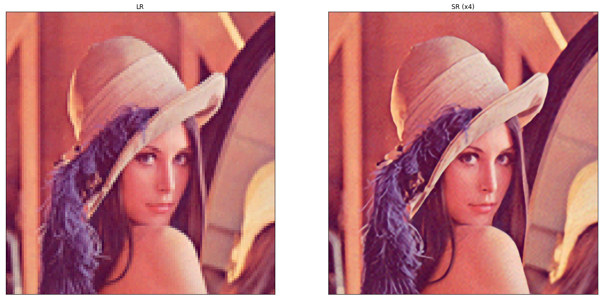

Figure 2: Result of Lena image on EDSR.

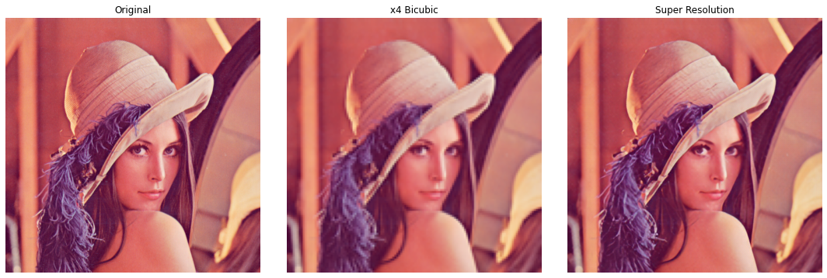
Figure 3: Result of Lena image on ESRGAN


Figure 4: Demo 1 on EDSR


Figure 5: Demo 2 on ESRGAN

